UNIT 1

Computer Applications

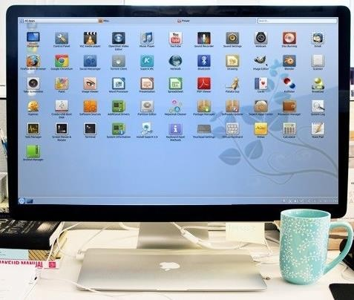
Picture 1.1

Learning Outcomes:
By the end of the lesson, the students are expected to be able to use appropriate English to:

- identify kinds of computer applications and their potential users

- identify and use Simple Present Tense for explaining their activities

- identify and use imperatives and sequencer in a text

- explain how to install a computer application using imperatives and sequencers

Kinds of computer applications and its potential users.

Exercise 1: Look at the following set of pictures on computer applications. Complete the table. Try to predict who is going to use each of the programs. An example has been given for you.

    - Adobe Premiere Pro b. Blender
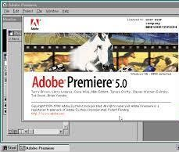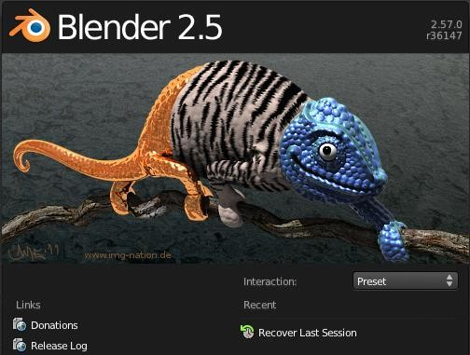

Picture 1.2 Picture 1.3

c. Cash Register d. Google Earth
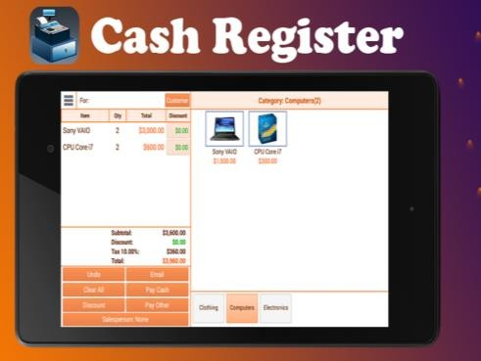
Picture 1.4 Picture 1.5

e. PrognoCIS f. VSCO
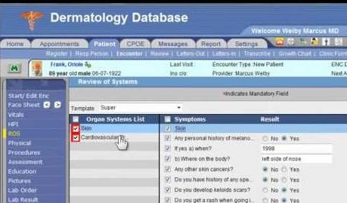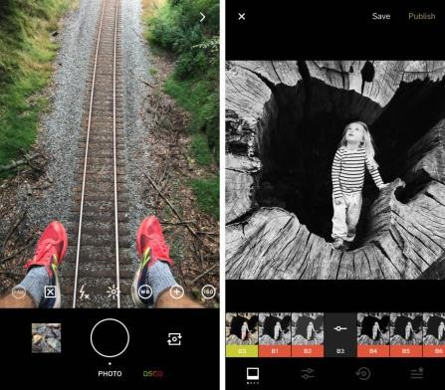
Picture 1.6 Picture 1.7

No. | Name of Applications | Uses | Potential Users
a. | Adobe Premiere | - to edit videos  - To create project music  - To create project film  - To create video documentation | - student  - content creator  - video editor
b. | Blender | To create animation film  To create visual effect  To create 3d model | Student  Animator
c. | Cash Register | To calculate and record sales report  Logs transactions that occur in your store, creating a record of the money coming in and going out. | Cashier  Manager cashier
d. | Google Earth | Visualize and analyze satellite images of our planet. | Traveller  Scientist  Geographer  Crimatology  People who want earth virtually
e. | PrognoCIS | System management | Doctor  Dermatologist
f. | Vsco | To edit photos | Phothographer  Editor  Content Creator

Exercise 2: Listen to four people talking about how they use computers at work. Complete the

table while listening and choose each of the speaker’s job from the box below.

electrical engineer
secretary
librarian
composer

Speakers | Job | What they use computers for
1. | composer | Keyboard connected to the computer, stores all the effect and synths.make and record the music
2. | secretary | Writing memos, emails, faxes and contacting offices overseas
3. | Electrical engineer | Calculate how many wattage does a room need, how long a cable should be. To draw a rough design or a prototype of a room’s electrical wiring.,
4. | Librarian | Classified and categorized dvd, magazines, and also stores all password. To easily find a spesific book in the library, also to print and use fax.

Exercise 3: Think and decide what computer application each of the speakers is used to help

his/her work

Speakers | Computer Applications They are likely Used
1. | Abelton, FL studio, Apple Logic Pro, Notion 6, Muscore
2. | Microsof Word, Google docs, Gmail, Yahoo! Mail
3. | AutoCAD
4. | Library Application

Exercise 4: Read the text about The Digital Age carefully, then discuss with your partner about

“How people nowadays use computers”.

The Digital Age
We are now living in what some people call the digital age, meaning that computers have become an essential part of our lives. Young people who have grown up with PCs and mobile phones are often called the digital generation. Computers help students to perform mathematical operations and improve their mathematics skills. They are used to access the internet to do basic research and communicate with other students around the world. Teachers use projectors and interactive whiteboards to give presentations and teach sciences, history, or language courses. PCs are also used for administrative purposes - schools use word processors to write letters, and database to keep records of students and teachers. A school website allows teachers to publish exercises for students to complete online. Students can also enroll for courses via the website and parents can download official reports.
Mobiles let you make video calls, send texts, email people and download logos, ringtones or games. With a built-in camera you can send pictures and make video calls in face-to-face mode. New smartphones combine a telephone with web access, video, a game console, an MP3 player, a personal digital assistant (PDA) and a GPS navigation system, all in one.
In banks, computers store information about money held by each customer and enable staff to access large databases and to carry out financial transactions at high speed. They also control the cashpoints, or ATMs (Automatic Teller Machines) which dispense money to customers by the use of a PIN-protected card. People use a chip and PIN card to pay for goods and services. Instead of using a signature to verify payments. customers are asked to enter a four-digit personal identification number (PIN), the same number used at cashpoints, this system makes transactions more secure. With online banking, clients can easily pay bills and transfer money from the comfort of their homes.
Airline pilots use computers to help them control the plane. For example, monitors display data about fuel consumption and weather conditions. In airport control towers, computers are used to manage radar systems and regulate air traffic. On the ground, airlines are connected to travel agencies by computer. Travel agents use computers to find out about the availability of flights, prices, times, stopovers, and many other details.
Infotech English for Computer Users (2011: 2-3)

Exercise 5: Match the words in column A (1-10) with their meanings in column B (a-j).

1. perform b | a. keep, save
2. word processor i | b. execute, do
3. online f | c. monetary
4. download a | d. screen
5. built-in e | e. integrated
6. digital | f. connected to the internet
7. store | g. collection of facts and figures
8. financial c | h. describes information
9. monitor d | i. program used for text manipulation
10. data g | j. copy files from a server to your PC or mobile

Exercise 6: Go back to Exercise 4. Look at the text. The underlined sentences that are written in

simple present tense. When you are talking about facts or routine, you use present simple tense. Look at the examples below:
Computers help students to perform mathematical operations and improve their mathematics

skills.

Teachers use projectors and interactive whiteboards to give presentations and teach sciences,

history, or language courses.

A school website allows teachers to publish exercises for students to complete online.

English for Informatics 1: Seventh Edition

Can you find more sentences using this tense? Write them down here:

Look at the explanation about Simple Present Tense:

The present tense is the base form of the verb  But the third person (she/he/it) adds an -s | - I work in a multimedia company.  - She works in a multimedia company.

We use Simple Present Tense to talk about:

1. something that is true in the present | - He studies C++ language programming this semester.  - I’m an Information Technology  student.
2. something that happens again and again in the present or routine  We use words like sometimes, often, always, and never (adverbs of frequency) with the present  tense | - I play online games every weekend.  - I sometimes play online games with my friends.  - She never plays online games.
3. something that is always true or  facts | - Light travels at almost 300,000  kilometers per second.

4. something that is fixed in the future | - The school term starts next week.  - The train leaves at 09.45 this evening.  - We have a test next week.

Exercise 7: Use present simple to write sentences that describes four different functions of

present simple tense.

Exercise 8: Write down how you use your computer to help you both study and do your hobbies

or free-time activities.

On my free time I use computer to
However, when I study I use computer to

  - Sequencing in giving instruction on how to install a computer software application. Exercise 9: Have you ever installed a program in your computer? What are they? Do you have difficulties? How do you solve the problems?

Exercise 10: Study these instructions on how to format a computer and install Windows. Pay attention to the italic and underline words.


When you want to format and install Windows 10 on your PC, what you need to prepare is Windows 10 installation disc. Make sure that it is original one since you need a serial number or a product key to complete the installation process. Moreover, you need to follow these following steps. First, insert the Windows 10 installation disc in your computer and restart the computer. When the prompt appears, press any key on your keyboard to begin the installation process during the boot procedure. Second, click "Next" on the first installer prompt that appears. After that, click "Install Now." Check the license term box and click "Next." Click "Custom (Advanced)" to access the installation option that allows you to format your hard drive. Select the hard drive or partition that you wish to format. Click "Next." Enter the username that you want to assign to your computer. Then, create a computer name. Click "Next." Provide a password for this account. Confirm the password and click "Next." Type in the Windows product key for the installation disc. Click "Next." Select the type of automatic updating you would like to run on the computer. Set the date and time. Click "Next." Click "Work Network." Finally, the formatted Windows installation is complete.
How to Format Computer and Install Windows, www.ehow.com.

Exercise 11: Find words in the text that match the definitions below.
- start again
- a secret code used to control access to a network system
- a number that uniquely identifies a product
- split a hard drive into parts that act like separate drives
- a series of actions to do something
- rules about how you can use software
- copy a part of the operating system into memory to allow a computer to start up.

Exercise 12: Go back to the text above. Observe the underlined and italic words. When you want to give instructions or describe a process of something, you need to use imperatives form and sequencers. The underlined words are examples of imperatives, whereas the italic words are examples of sequencers.

Imperatives | Insert the Windows 7 installation disc in your computer and restart the computer. Check the license term box and click "Next."  Select the hard drive or partition that you  wish to format.

Sequencers | First, insert the Windows 7 installation disc in your computer and restart the computer. After that, click "Install Now.  Then, create a computer name.  Finally, the formatted Windows installation is complete.

Exercise 13: Write down an instruction of installing a program (software) to your personal computer (PC) and present it in front of the class (use Power Point and provide screenshots of each process to help your presentation). Do not forget to use imperatives and sequencers you have just learned. See the example below.

How to Install Dropbox
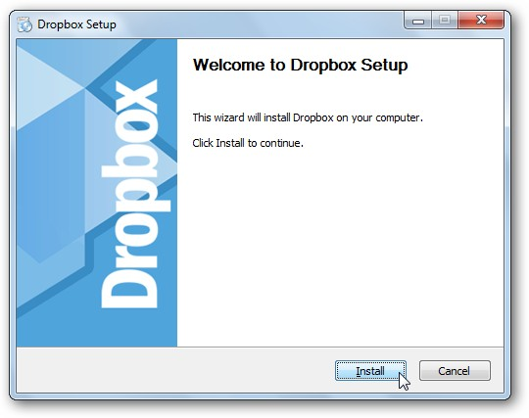
Dropbox is a software used to store our data both in our PC and website. It is also functioned as a data back up when our PC is in trouble and cannot be accessed. To install Dropbox to your PC, the first thing that you should do is go to https://www.dropbox.com/downloading to get the installer. Next, click Save File button then wait until the download is complete. When the
download is complete, then run the installer. You will see the set-up wizard and begin the installation process by clicking Install button.

